### Aggregation to countries and disciplines

Following Zit and Bassecoulard (1999), the evidence from journals is aggregated to the level of countries and disciplines.

The aggregated figures are calculated as an average of the journal-level indicator weighted by the journal’s share on the country total documents in the respective discipline.

Only results of the aggregation procedure based on data from at least 30 journals are reported.

#### Definitions

Globalization of science in the country c, discipline d and in year y measured by the indicator i is calculated as follows:

Gc,d,y,i=J∑j=1aj,c,d,y gj,d,y,i(.)

aj,c,d,y is the share of documents with authors from the country c in the journal j on all documents of the country c in the discipline d in the year y.

gj,d,y,i(.) is the globalization indicator i of journal j in the discipline d in the year y.

#### Standardization and scaling

Subsequently, the aggregated globalization index was standardized between 0 and 1 and converted to ascending scale to simplify interpretation of the results:

GSc,d,y,i=Gc,d,y,i−Gmini / Gmaxi−Gmini \* alphai

where Gmini,i and Gmax,i is minimum and maximum value of the indicator i across all years, countries and disciplines and alphai equals to -1 for the minimizing indicator (i.e. low values for high globalization) and 1 otherwise, as the results of which 0 refers to the lowest and 1 to the highest globalization.

**Database**

Scopus Source List (May 2018 version) provided International Standard Serial Numbers (ISSNs), classification by disciplines and publisher’s domicile of 34 965 academic journals.

In August 2018, detailed data on authors by the country of origin and language of documents in these ISSNs were downloaded from the Scopus citation database over the period from 2005 to 2017.

Only document types of a journal article, review and conference papers, i.e. the so-called “citable documents”, are included in this analysis.

The following Scopus API request was used to download the data:

ISSN(AAAA-BBBB) AND DOCTYPE(AR OR RE OR CP) AND PUBYEAR = YYYY

where *AAAA-BBBB* is the journal's ISSN and *YYYY* is the year.

**Local Journals in Scopus**

In this study, Vít Macháček and Martin Srholec analysed local academic publishing in selected European countries over the period 2013-2016.

The results revealed strong tendency to publish locally in the former communist countries. Local journals are prevalent in Croatia, Romania, Slovenia, Lithuania or Czechia but rather rare in comparable advanced countries.

In Czechia, for instance, nearly one fifth of all indexed results are concentrated in Czech journals with a high percentage (>33%) of articles by domestic authors. About half of authors contributing to Czech journals are based in Czechia, and another tenth in Slovakia.

In contrast, the vast majority of articles which come out in journals published in comparable advanced countries are written by foreigners. The publishing of national, or at best regional, indexed journals appears to be a distinctly Eastern European phenomenon.

**Local Journals in selected EU and OECD countries (2013-2016)**

(% of authors form the same country as the journal publisher)

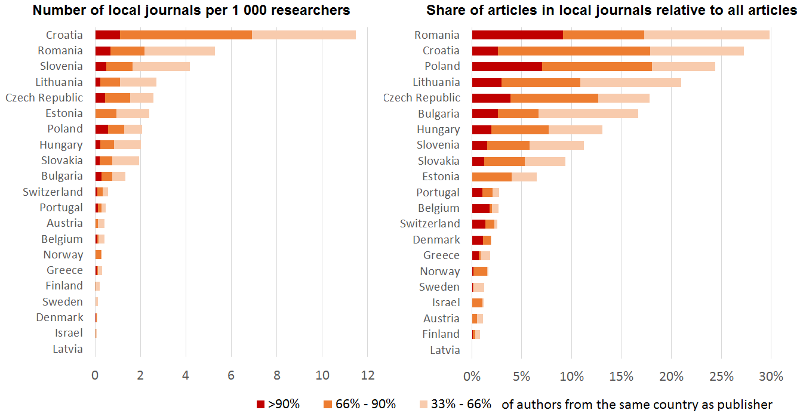

*Note: Number of active journals with more than 30 articles over 2013-2016; number of researchers in the latest available year in full time equivalent.*

*Source: Scopus (April and October 2017), Eurostat, OECD, Scimago, authors' calculations.*

Macháček, V. and Srholec, M. (2017) Local Journals in Scopus (only in Czech). IDEA think-tank at CERGE-EI, Study 17/2017.

**Predatory Journals in Scopus**

In this study, Vít Macháček and Martin Srholec mapped patterns of predatory publishing across the globe over the period 2015-2017.

The analysis is based on Beall's lists of "potentially predatory" journals and publishers, of which we found 3 218 journals in Ulrichsweb and 405 journals in Scopus.

The results shows that predatory publishing has become most widespread in middle-income countries in Asia and North Africa.

However, the analysis also indicates that Beall’s lists need to be used with caution, as some of the implicated journals may not be necessarily fraudulent.

**Share of predatory articles on total number of articles (2015-2017)**

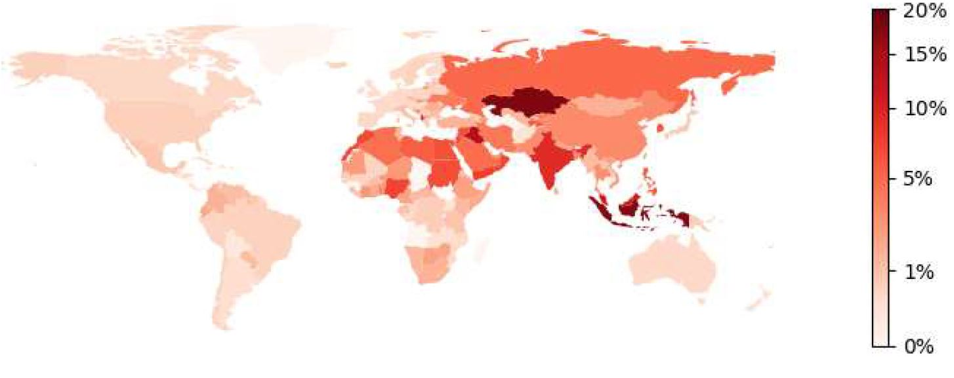

*Note: Ain journals published bythe Frontiers Research Foundation are.*

*Scopus (October 2016), Beall's lists (April 2016), authors' calculations.*

Macháček, and Srholec, M. (2016) Predatory Journals in Scopus. IDEA think-tank at CERGE-EI, Study 2/2017.

### Country groups

##### Development status

**Advanced countries**: Australia, Austria, Belgium, Canada, Cyprus, Denmark, Finland, France, Germany, Greece, Hong Kong, Iceland, Ireland, Israel, Italy, Japan, Liechtenstein, Luxembourg, Monaco, Netherlands, New Zealand, Norway, Portugal, Singapore, South Korea, Spain, Sweden, Switzerland, Taiwan, United Kingdom, United States.

**Transition countries**: Albania, Armenia, Azerbaijan, Belarus, Bosnia and Herzegovina, Bulgaria, Croatia, Czechia, Estonia, Georgia, Hungary, Kazakhstan, Kyrgyzstan, Latvia, Lithuania, Macedonia, Moldova, Mongolia, Montenegro, Poland, Romania, Russia, Serbia, Slovakia, Slovenia, Tajikistan, Turkmenistan, Ukraine, Uzbekistan.

**Developing countries**: Rest of the world.

Source: IMF (2003) [World Economic Outlook](https://www.imf.org/external/pubs/ft/weo/2003/02/" \t "_blank) (Statistical Appendix; pp .163-169).

**High income, Upper middle income, Lower middle income and Low income** depending on Gross National Income (GNI) per capita in US$ (Atlas methodology).

Source: World Bank (2018) How does the World Bank classify countries? (version of August??? 2018).

##### Regions

Europe, North America, South America, Central Asia, Middle East, East Asia, South Asia, Pacific, North Africa, Sub-Saharan Africa based on geography and administrative borders.

Source: World Bank (2018) How does the World Bank classify countries? (version of August??? 2018).

##### Other

EU-15: "Old" EU member countries (before 2004).

EU-13: "New" EU member countries (accessed between 2004 and 2018).

EU-28: EU-15 and EU-13 combined.

OECD: OECD member countries (August??? 2018)

xxxxxx

Odkaz na References dát až na poslední stranu aplikace… updatovat ho (nechat tam pouze odkazy, které jsou někde zmíněné v textu) a formát odkazů udělat podle šablony, která je v těch dvou pop-up oknech výše.